
FrostCast – Intelligent Vaccine Box Monitoring and Early Warning System
A MINI PROJECT REPORT

Submitted by
HARSHINI M  VYBHAVI R  SATVEKA A  SURUTHI S | 25EC074  25EC248  25EC206  25EC231

BACHELOR OF ENGINEERING
in
ELECTRONICS AND COMMUNICATION ENGINEERING

KPR INSTITUTE OF ENGINEERING AND TECHNOLOGY (AUTONOMOUS)
ARASUR, COIMBATORE 641 407

ANNA UNIVERSITY :: CHENNAI 600 025

OCTOBER 2026
ANNA UNIVERSITY : CHENNAI 600025

BONAFIDE CERTIFICATE

Certified that this project report titled “FrostCast – Intelligent Vaccine Box Monitoring and Early Warning System” is the bonafide work of “HARSHINI M, VYBHAVI R and SATVEKA A , SURUTHI S” who carried out the project work under my supervision.

SIGNATURE | SIGNATURE
Dr. M.KATHIRVELU | Dr. K.MURUGAN
 | ASSOCIATE PROFESSOR ,
HEAD OF THE DEPARTMENT, | SUPERVISOR,
Department of Electronics and Communication Engineering,  KPR Institute of Engineering and Technology, Arasur,  Coimbatore – 641 407. | Department of Electronics and Communication Engineering,  KPR Institute of Engineering and Technology, Arasur,  Coimbatore – 641 407.

Submitted for Mini project evaluation conducted on …………….

Recommended for STRIDE Score ……..……………..
Name & Signature
SKILL OFFICER

ACKNOWLEDGMENT

We express our sincere thanks and profound gratitude to Dr. K. P. Ramasamy, Chairman, and Ms. Gayathri Anandakrishnan, Secretary, KPR Group of Institutions, for providing an excellent academic environment and for their visionary leadership and unwavering support for research and innovation.

We are deeply grateful to Dr. M. Akila, Principal, KPR Institute of Engineering and Technology, for her esteemed guidance and for fostering a culture of academic excellence.

We are especially thankful to Dr. Dr. M.KATHIRVELU, Professor and Head, Department of Electronics and Communication Engineering, for his support. We owe our deepest gratitude for our project supervisor, Dr. K.MURUGAN, Associate Professor , Department of Electronics and Communication Engineering, whose expert guidance, immense patience, and constant encouragement have been the cornerstones of this endeavour.

We also extend our heartfelt thanks to our beloved family, faculty members, supporting staffs and friends for their unwavering support and motivation.

HARSHINI M | (25EC074)
VYBHAVI R | (25EC248)
SATVEKA A ( | 25EC206)
SURUTHI S | (25EC)

ABSTRACT

FrostCast – Intelligent Vaccine Box Monitoring and Early Warning System
Maintaining suitable temperature conditions during vaccine storage and transportation is essential for preserving vaccine quality and effectiveness. Temperature fluctuations and improper handling can create risks during vaccine transportation. FrostCast – Intelligent Vaccine Box Monitoring and Early Warning System is designed to monitor the environmental conditions and location of a vaccine box during transportation.
The system uses an ESP32 microcontroller to collect temperature and humidity data from a DHT22 sensor. An MPU6050 accelerometer and gyroscope module is used to detect changes in the movement and orientation of the vaccine box. A GPS module provides location information, while an SX1278 LoRa module enables wireless communication between the transmitter and receiver units. A GSM module supports remote alert notifications, and an OLED display and buzzer provide local status information and warnings.
The system allows the operator to monitor temperature, humidity, movement, and location information during transportation. A web-based dashboard can display sensor readings and alerts, helping users observe the condition of the vaccine box. These features support timely identification of abnormal conditions and improve the visibility of vaccine transportation.
In conclusion, FrostCast provides an IoT-based approach to vaccine box monitoring by integrating environmental sensing, movement detection, GPS tracking, wireless communication, and alert mechanisms. Future enhancements may include predictive temperature early warnings and AI-based sensor fault detection to further improve monitoring capabilities and support proactive vaccine cold-chain management.

TABLE OF CONTENTS

CHAPTER  NO. | TITLE | PAGE NO.
 | ACKNOWLEDGMENT | iii
 | ABSTRACT | iv
 | LIST OF FIGURES | viii
 | LIST OF TABLES | ix
 | LIST OF ABBREVATIONS | x
1. | INTRODUCTION | 01
 | 1.1 OBJECTIVE | 01
 | 1.2 OVERVIEW | 01
 | 1.3 DIRECT BENEFITS | 03
 | 1.4 INDIRECT BENEFITS | 03
 | 1.5 ORGANIZATION OF THE REPORT | 04
2. | REVIEW OF LITERATURE | 05
 | 2.1 RELATED BACKGROUNDS | 05
3. | SYSTEM IMPLEMENTATION | 15
4. | RESULT | 33
5. | CONCLUSION AND FUTURE TRENDS | 44
 | APPENDIX I | 46
 | REFERENCES | 53

LIST OF FIGURES

FIGURE NO | FIGURE NAME | PAGE NO
4.1 | Overall System Architecture of FrostCast | 43
4.2 | Block Diagram of the Proposed System | 44
4.3 | Hardware Components of FrostCast | 46
4.4 | Transmitter and Receiver Setup | 47
4.5 | FrostCast Web Monitoring Dashboard | 49

LIST OF ABBREVATIONS

LIST OF ABBREVIATIONS
S. NO | ABBREVIATION | EXPANSION
1 | AI | Artificial Intelligence
2 | IoT | Internet of Things
3 | ESP32 | ESP32 Microcontroller
4 | DHT22 | Digital Temperature and Humidity Sensor
5 | MPU6050 | 6-Axis Motion Tracking Sensor
6 | GPS | Global Positioning System
7 | GSM | Global System for Mobile Communications
8 | LoRa | Long Range
9 | OLED | Organic Light-Emitting Diode

INTRODUCTION
1.1 OBJECTIVE
The main objective of FrostCast is to develop an intelligent vaccine box monitoring system that monitors temperature, humidity, movement, and location during transportation. The system uses an ESP32 microcontroller with a DHT22 sensor and an MPU6050 sensor to collect environmental and movement data. GPS is used for location tracking, while LoRa enables wireless communication between the transmitter and receiver. GSM alerts, an OLED display, and a buzzer help provide timely information about the vaccine box condition.
1.2 OVERVIEW
FrostCast is an IoT-based vaccine box monitoring system designed to improve monitoring during vaccine transportation. The ESP32 collects temperature and humidity readings from the DHT22 sensor and movement data from the MPU6050 sensor. A GPS module provides location information, and an SX1278 LoRa module transmits data between the transmitter and receiver units. A GSM module supports remote alerts, while an OLED display and buzzer provide local status updates and warnings. A web dashboard can display sensor readings, location details, and alerts, allowing operators to monitor the vaccine box more conveniently. Predictive early warning and AI-based sensor fault detection are considered future enhancements.

1.3 DIRECT BENEFITS
1. Real-Time Temperature and Humidity Monitoring: Continuously monitors the temperature and humidity inside the vaccine box using the DHT22 sensor.
2. Detection of Vaccine Box Tilt and Movement: Uses the MPU6050 sensor to detect unusual tilting and movement during transportation.
3. GPS-Based Location Tracking: Tracks the vaccine box location using GPS coordinates during transportation.
4. Wireless Data Transmission Using LoRa: Transfers sensor readings and status information between the transmitter and receiver units.
5. Instant Alerts Through a Buzzer and GSM: Provides local warnings through a buzzer and supports remote notifications through the GSM module.
6. Easy Monitoring Through a Web Dashboard: Displays sensor readings, location details, and alerts through a user-friendly web interface.

1.4 INDIRECT BENEFITS

1. Helps Maintain Vaccine Quality: Supports proper monitoring of environmental conditions during vaccine transportation.
2. Reduces Vaccine Wastage: Early warnings may help prevent avoidable losses caused by unnoticed temperature problems.
3. Improves Transportation Safety: Monitors environmental conditions and box movement to identify potential risks.
4. Reduces Manual Monitoring Work: Automates sensor data collection and reduces the need for frequent manual checking.
5. Supports Faster Decision-Making: Provides timely alerts and monitoring information to help operators take appropriate action.
6. Improves Shipment Tracking: GPS information helps personnel identify the location of the vaccine box during transportation.
7. Helps Healthcare Workers Respond Quickly: Provides alerts that help healthcare personnel investigate potential problems promptly.
8. Supports Efficient Cold-Chain Management: Combines monitoring, tracking, and alerts to improve the management of vaccine transportation.

1.5 ORGANIZATION OF THE REPORT

This report is organized into ten chapters.
- Chapter 1 – Introduction: Explains the objectives, overview, and benefits of FrostCast.
- Chapter 2 – Problem Statement: Describes the problem and project objectives.
- Chapter 3 – Existing and Proposed Systems: Discusses existing methods and the proposed solution.
- Chapter 4 – System Requirements: Lists the hardware and software requirements.
- Chapter 5 – System Design: Explains the system architecture and block diagram.
- Chapter 6 – Hardware Components: Describes the components used in the project.
- Chapter 7 – Software Methodology: Explains predictive warnings and AI-based sensor fault detection.
- Chapter 8 – Implementation: Describes hardware integration and dashboard development.
- Chapter 9 – Testing and Results: Presents the testing process and results.
- Chapter 10 – Conclusion and Future Scope: Summarizes the project and future improvements.

REVIEW OF LITERATURE
2.1 RELATED BACKGROUNDS
Vaccine transportation requires proper temperature monitoring to maintain vaccine quality and effectiveness. Traditional monitoring methods often depend on manual temperature checking or basic monitoring devices, which may provide limited information about environmental conditions and shipment location. Therefore, IoT-based monitoring systems can help improve the observation and management of vaccine transportation.
Temperature and humidity sensors are commonly used to monitor environmental conditions. Microcontrollers such as the ESP32 can collect and process sensor readings. Motion sensors, such as the MPU6050, can identify changes in the movement and orientation of a vaccine box. GPS technology helps track the shipment location, while wireless communication technologies such as LoRa support data transmission between monitoring units.
GSM communication can be used to send remote notifications, while displays and buzzers provide local information and alerts. A web-based dashboard can also present sensor readings, location details, and warning messages in an accessible format.
Based on these technologies, FrostCast integrates an ESP32, DHT22 sensor, MPU6050 sensor, GPS module, SX1278 LoRa module, GSM module, OLED display, and buzzer. The system aims to monitor environmental conditions, detect unusual movement, track the vaccine box location, and provide timely alerts during transportation. Predictive early warning and AI-based sensor fault detection may be considered as future enhancements.

SYSTEM IMPLEMENTATION
Problem Statement
Maintaining suitable temperature conditions during vaccine transportation is important for preserving vaccine quality. Temperature variations, improper handling, and limited shipment tracking can create challenges during transportation. Manual monitoring may not provide continuous information about temperature, humidity, movement, and location.
To address these challenges, FrostCast is designed to monitor vaccine box conditions using an ESP32 microcontroller, DHT22 temperature and humidity sensor, and MPU6050 motion sensor. A GPS module tracks the box location, while an SX1278 LoRa module enables wireless communication between the transmitter and receiver units. A GSM module supports remote alerts, and an OLED display and buzzer provide local status information and warnings.
The system aims to help operators monitor environmental conditions, identify unusual movement, track the vaccine box, and respond to alerts during transportation. A web dashboard can display sensor readings, location details, and alerts in one place.

EXISTING AND PROPOSED SYSTEMS
Existing System
Existing vaccine transportation methods may use manual temperature checks or basic monitoring devices to observe storage conditions. These methods can have limitations in continuous monitoring, movement detection, location tracking, and remote alert notifications. Manual checking may also delay the identification of potential problems during transportation.
Proposed System
FrostCast is designed to monitor vaccine box conditions using an ESP32 microcontroller and a DHT22 temperature and humidity sensor. An MPU6050 sensor detects movement and changes in orientation, while a GPS module provides location information. An SX1278 LoRa module enables wireless communication between the transmitter and receiver units.
A GSM module supports remote alerts, while an OLED display and buzzer provide local status information and warnings. A web dashboard can display sensor readings, location details, and alerts for convenient monitoring.
The proposed system combines environmental monitoring, movement detection, location tracking, wireless communication, and alert mechanisms to improve the monitoring of vaccine transportation.
SYSTEM REQUIREMENTS

Hardware Requirements
- ESP32 Microcontroller: Processes sensor data and controls the system.
- DHT22 Sensor: Measures temperature and humidity.
- MPU6050 Sensor: Detects movement and tilt.
- GPS Module: Tracks the vaccine box location.
- SX1278 LoRa Module: Enables wireless communication between transmitter and receiver.
- GSM Module: Sends remote alerts.
- OLED Display: Displays sensor readings and system status.
- Buzzer: Provides audible warnings.

Software Requirements
- Arduino IDE: Used to program the ESP32.
- Embedded C/C++: Used to develop the microcontroller code.
- Sensor Libraries: Support communication with the DHT22 and MPU6050.
- GPS Library: Processes location data.
- LoRa Library: Handles wireless data transmission.
- GSM Communication Code: Supports remote alert notifications.
- Web Dashboard Software: Displays sensor readings, location information, and alerts.

5.1 SYSTEM DESIGN
The system design of FrostCast – Intelligent Vaccine Box Monitoring and Early Warning System describes the overall structure, arrangement, and interaction of the hardware and software components used to monitor a vaccine box during transportation. The system is designed to monitor environmental conditions, detect box movement, track location, transmit sensor data, and provide alerts when necessary.
FrostCast is organized into two main units: the transmitter unit and the receiver unit. The transmitter unit is placed with the vaccine box and collects information using sensors. The receiver unit receives the transmitted data and makes it available for monitoring. This arrangement allows the vaccine box to be monitored during transportation without requiring the operator to remain physically beside it.
The ESP32 microcontroller acts as the main processing unit of the transmitter. It receives readings from the DHT22 temperature and humidity sensor and the MPU6050 motion sensor. The GPS module provides location information, while the SX1278 LoRa module transmits the collected data to the receiver. A GSM module supports remote alert notifications. An OLED display and buzzer provide local status information and audible warnings.
The system is designed to combine these components into a single monitoring solution. The collected information helps the operator observe the condition and location of the vaccine box throughout transportation.

5.2 SYSTEM ARCHITECTURE
The FrostCast system architecture illustrates how data moves from the sensors to the microcontroller and then to the monitoring and alert components.
The DHT22 sensor measures the temperature and humidity inside the vaccine box. The MPU6050 sensor detects changes in movement and orientation. The GPS module obtains location coordinates when satellite signals are available. These components provide different types of information about the vaccine shipment.
The ESP32 collects and processes the available sensor data. Based on the programmed conditions, it updates the OLED display, activates the buzzer when required, and sends information through the LoRa transmitter. The receiver unit uses an SX1278 LoRa module to receive the transmitted data. The received information can then be presented through a monitoring interface or web dashboard, depending on the implemented software.
The GSM module provides a separate communication path for remote notifications, subject to network availability and the implemented connection. Thus, the system supports both local monitoring and remote access to relevant shipment information.

5.3 TRANSMITTER UNIT DESIGN
The transmitter unit is installed with the vaccine box and is responsible for collecting sensor readings and transmitting information to the receiver.

5.3.1 ESP32 Microcontroller
The ESP32 is the central controller of the transmitter unit. It interfaces with the sensors and communication modules, processes the incoming information, and controls the output devices. It coordinates temperature and humidity monitoring, movement detection, GPS data collection, LoRa transmission, and local alerts.

5.3.2 DHT22 Temperature and Humidity Sensor
The DHT22 measures the temperature and humidity surrounding the sensor inside the vaccine box. Its readings are sent to the ESP32 for processing and monitoring. These measurements help the operator observe environmental changes during transportation and identify conditions that may require attention.

5.3.3 MPU6050 Motion Sensor
The MPU6050 combines an accelerometer and a gyroscope to measure acceleration and angular movement. The ESP32 uses this information to identify changes in the vaccine box's movement and orientation. The system can be programmed to recognize unusual tilting or movement according to selected thresholds.

5.3.4 GPS Module
The GPS module provides geographic coordinates during transportation when sufficient satellite signals are available. The ESP32 can collect the location information and include it in the transmitted data. This enables the operator to view the approximate location of the vaccine box through the monitoring interface when location data is available.

5.3.5 SX1278 LoRa Transmitter
The SX1278 LoRa module provides wireless communication between the transmitter and receiver units. It sends the sensor readings, movement information, and available GPS data to the receiver. LoRa is suitable for low-power communication, although its practical range depends on the antenna, surrounding environment, and installation conditions.

5.3.6 GSM Module
The GSM module supports remote alert notifications. When a programmed warning condition occurs, the ESP32 can use the GSM module to send a notification through the available cellular network. The exact alert method depends on the GSM module and communication code used in the implementation.

5.3.7 OLED Display and Buzzer
The OLED display presents selected sensor readings and system status near the vaccine box. The buzzer provides an audible warning when a programmed alert condition is detected. These outputs help nearby personnel identify important changes without needing to access the web dashboard.

5.4 RECEIVER UNIT DESIGN
The receiver unit is responsible for receiving information transmitted by the vaccine box. It contains an SX1278 LoRa receiver that communicates with the transmitter's LoRa module using compatible radio settings.
When data arrives, the receiver processes the received message and forwards it to the monitoring interface according to the implemented software design. The displayed information may include temperature, humidity, movement status, and GPS coordinates. This allows the operator to observe the available shipment information from a separate location within the communication range.
The receiver must use compatible LoRa frequency, configuration, and message format settings with the transmitter. Reliable reception also depends on antenna placement, distance, obstacles, and radio interference.

5.5 DATA FLOW AND WORKING PRINCIPLE
The FrostCast system follows a sequence of data collection, processing, communication, and display.
First, the DHT22 measures temperature and humidity, while the MPU6050 provides movement and orientation information. The GPS module obtains the available location coordinates. The ESP32 reads the data from these components and processes it according to the program.
Next, the ESP32 updates the OLED display and checks whether any programmed warning conditions require the buzzer or a GSM notification to be activated. The collected information is also transmitted through the SX1278 LoRa module.
The receiver's LoRa module receives the transmitted message and passes the information to the monitoring interface. The web dashboard can display the available readings, location information, and alerts for the operator.
This process repeats at the programmed sampling and transmission intervals, allowing the operator to monitor changes during transportation. The accuracy and timeliness of the information depend on sensor performance, program settings, GPS availability, and communication reliability.

5.6 SYSTEM INTEGRATION
System integration involves connecting the sensors, microcontroller, communication modules, and output devices so they operate together correctly. The DHT22, MPU6050, and GPS module provide input data to the ESP32 through their respective interfaces. The LoRa and GSM modules handle communication, while the OLED display and buzzer provide local outputs.
During integration, the power supply, voltage compatibility, wiring, communication settings, and program logic must be checked. The transmitter and receiver must also be configured to exchange data correctly. Finally, the monitoring interface must be tested to ensure that received readings and alerts are displayed as expected.
Overall, the FrostCast system design combines environmental monitoring, movement detection, location tracking, wireless data transmission, and alert mechanisms. This architecture provides a practical foundation for monitoring vaccine box conditions during transportation.

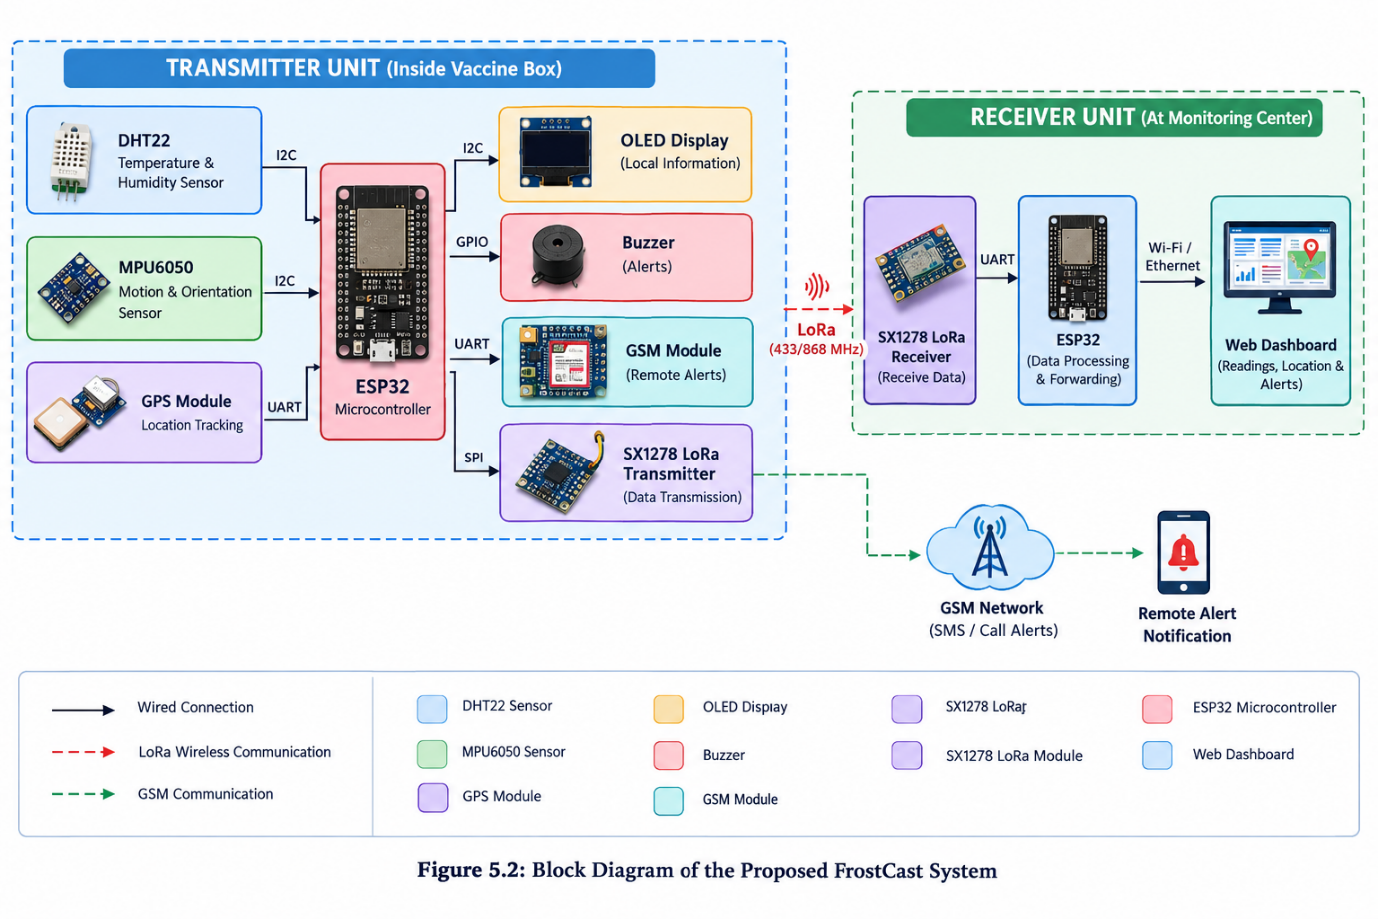
WORKING PROTOTYPE

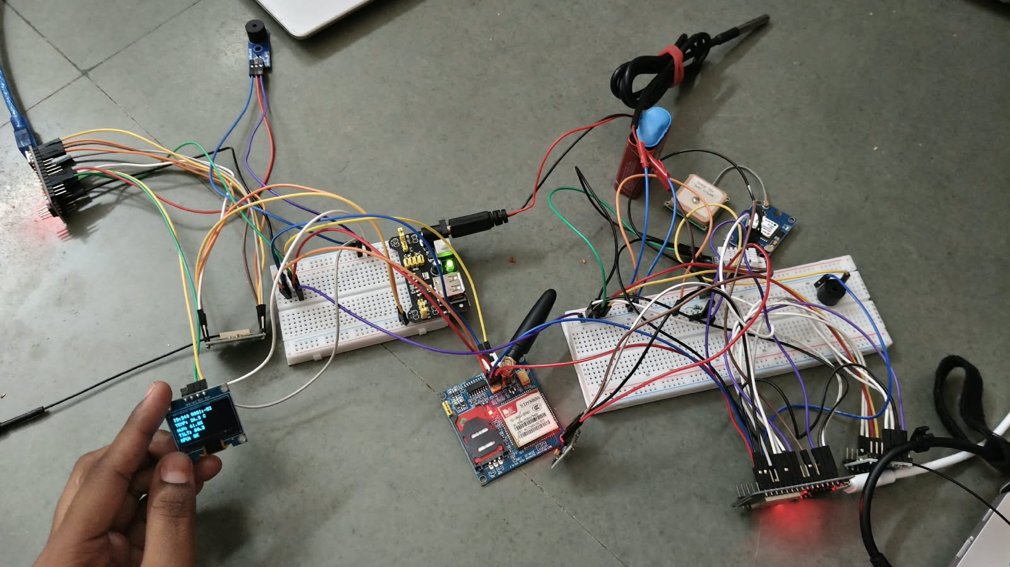
TESTING AND RESULTS
9.1 TESTING
FrostCast is tested to verify the working of its hardware components and monitoring functions.
- Temperature and Humidity Monitoring: The DHT22 sensor measures the temperature and humidity inside the vaccine box.
- Movement Detection: The MPU6050 sensor detects movement and changes in the orientation of the vaccine box.
- GPS Tracking: The GPS module provides the location coordinates of the vaccine box when a satellite signal is available.
- LoRa Communication: The SX1278 LoRa modules transmit monitoring data from the transmitter unit to the receiver unit.
- GSM Alerts: The GSM module sends remote notifications according to the programmed alert conditions.
- OLED Display: The OLED displays available sensor readings and system status.
- Buzzer Alert: The buzzer provides audible warnings when configured alert conditions occur.
- Web Dashboard: The dashboard displays available sensor readings, location information, and alerts.
9.2 RESULTS
FrostCast combines environmental monitoring, movement detection, location tracking, wireless communication, and alert mechanisms in one system. The ESP32 collects data from the connected sensors, and the LoRa modules support data transfer between the transmitter and receiver. The GSM module provides remote notifications, while the OLED display and buzzer provide local information and warnings. The web dashboard allows the operator to view available monitoring data.
The system helps operators monitor vaccine box conditions and location during transportation. Its effectiveness depends on proper hardware connections, sensor operation, communication availability, and the implemented software.
9.3 SUMMARY
The project integrates the DHT22, MPU6050, GPS, LoRa, GSM, OLED display, and buzzer with the ESP32 to support vaccine box monitoring. The web dashboard provides a convenient way to view sensor readings, location details, and alerts. Predictive early warning and AI-based sensor fault detection are planned as future enhancements.
CONCLUSION AND FUTURE SCOPE
10.1 CONCLUSION
FrostCast – Intelligent Vaccine Box Monitoring and Early Warning System is designed to monitor the environmental conditions, movement, and location of a vaccine box during transportation. The system uses an ESP32 microcontroller, DHT22 temperature and humidity sensor, MPU6050 motion sensor, GPS module, and SX1278 LoRa modules to collect and transmit monitoring data.
The GSM module supports remote alert notifications, while the OLED display and buzzer provide local status information and warnings. The web-based dashboard displays available sensor readings, location details, and alerts, helping operators monitor the vaccine box more conveniently.
Overall, FrostCast integrates environmental monitoring, movement detection, GPS tracking, wireless communication, and alert mechanisms into a single system. It helps improve visibility during vaccine transportation and supports timely responses to potential problems.
10.2 FUTURE SCOPE
The following enhancements can be added to FrostCast in the future:
- Predictive Temperature Early Warning: Develop a system to predict possible temperature deviations before they occur, allowing operators to take preventive action.
- AI-Based Sensor Fault Detection: Introduce artificial intelligence techniques to identify unusual sensor readings and potential sensor malfunctions.
- Improved Dashboard: Enhance the dashboard with additional monitoring features and clearer presentation of historical sensor data.
- Data Logging and History: Store monitoring records for later review and analysis of temperature, humidity, movement, and location.
- Improved Communication Reliability: Enhance communication reliability and data availability during vaccine transportation.
These future enhancements can improve the monitoring capabilities of FrostCast and support more effective vaccine cold-chain management.

